**SQL**

A database is a collection of organised or arranged data that can be easily accessed, updated/ modified or controlled. Information within the database can be easily placed into rows and columns, or tables.

* **What is a Database Management System (DBMS)?**

A database management system (or DBMS) is essentially nothing more than a computerized data-keeping system.

Database Management System (DBMS) is software used to identify, manage, and create a database that provides administered access to the data.

* **What is a Relational Database Management System (RDBMS)?**

The software used to store, manage, query, and retrieve data stored in a relational database is called a relational database management system (RDBMS).

The RDBMS provides an interface between users and applications and the database, as well as administrative functions for managing data storage, access, and performance.

Relational Database Management System (RDBMS) is a more advanced version of a DBMS system that allows access to data in a more efficient way. It is used to store or manage only the data that are in the form of tables.

|  |  |
| --- | --- |
| **RDBMS** | **DBMS** |
| Data stored is in table format | Data stored is in the file format |
| Multiple data elements are accessible together | Individual access of data elements |
| Data in the form of a table are linked together | No connection between data |
| Support distributed database | No support for distributed database |
| Data is stored in a large amount | Data stored is a small quantity |
| RDBMS supports multiple users | DBMS supports a single user |
| The software and hardware requirements are higher | The software and hardware requirements are low |
| Example: Oracle, SQL Server. | Example: XML, Microsoft Access. |

* **What is a SQL?**
* SQL stands for Structured Query Language
* SQL is a standard language for storing, manipulating and retrieving data in databases. SQL allows you to access and manipulate the databases. To use SQL in: MySQL, SQL Server, MS Access, Oracle, Sybase, Informix, Postgres, and other database systems.

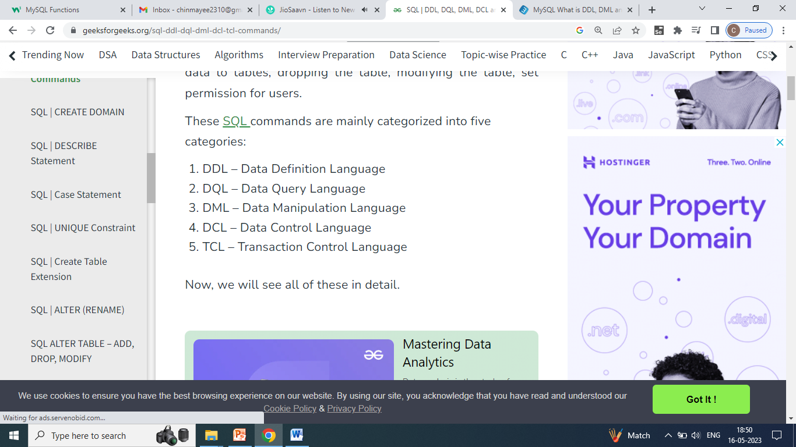

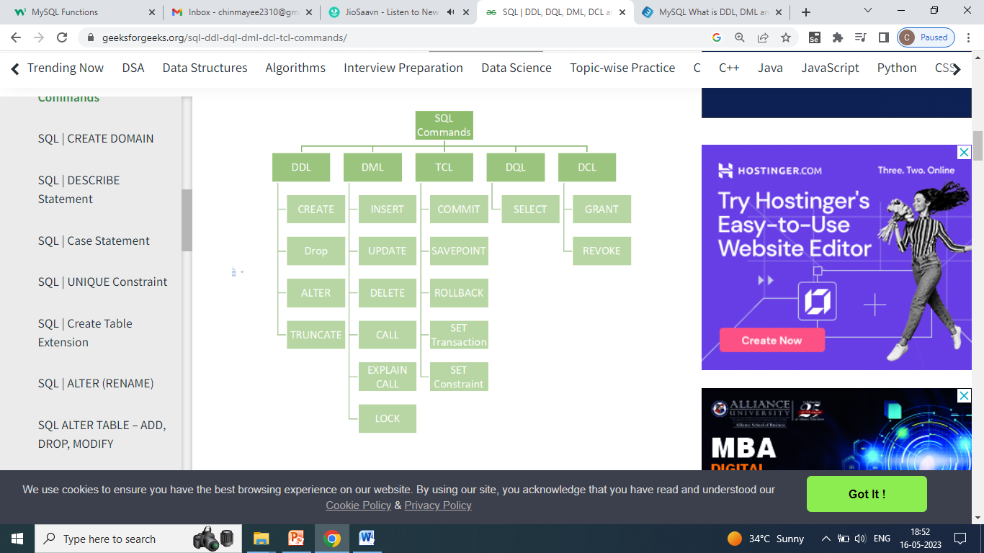

Data types

|  |  |
| --- | --- |
| **CHAR(size)** | A FIXED length string (can contain letters, numbers, and special characters). can be from 0 to 255. Default is 1 |
| **VARCHAR(size)** | A VARIABLE length string (can contain letters, numbers, and special characters). can be from 0 to 65535 |
| **INT(*size*)** | A medium integer. Signed range is from -2147483648 to 2147483647. Unsigned range is from 0 to 4294967295. |
| **INTEGER(*size*)** | Equal to INT(size) |
| **FLOAT(*p*)** | A floating point number. MySQL uses the *p* value to determine whether to use FLOAT or DOUBLE for the resulting data type. If *p* is from 0 to 24, the data type becomes FLOAT(). If *p* is from 25 to 53, the data type becomes DOUBLE() |
| **DATE** | A date. Format: YYYY-MM-DD. The supported range is from '1000-01-01' to '9999-12-31' |
| **DATETIME(*fsp*)** | A date and time combination. Format: YYYY-MM-DD hh:mm:ss. |
| **TIME(*fsp*)** | A time. Format: hh:mm:ss. The supported range is from '-838:59:59' to '838:59:59' |
| **YEAR** | A year in four-digit format. Values allowed in four-digit format: 1901 to 2155, and 0000. MySQL 8.0 does not support year in two-digit format. |

## SQL CREATE TABLE Statement

**CREATE TABLE** Employee (Emp_No int, Emp_Name varchar(50), Salary int);

## Create Table Using another Table

**CREATE TABLE** TestEmployee **AS SELECT** Emp_No, Emp_Name **FROM** Employee;

## The SQL DROP TABLE Statement

**DROP TABLE** TestEmployee;

## SQL TRUNCATE TABLE

**TRUNCATE TABLE** TestEmployee;

To delete the data inside a table, but not the table itself.

## The SQL INSERT INTO Statement

1. **INSERT INTO** Employee **VALUES**(101,’Chinmayee’, 50000);
2. **INSERT INTO** Employee  (Emp_No, Emp_Name) **VALUES** (101,’Chinmayee’);

The rest field will contain NULL value automatically. E.g here about Salary.

## The SQL SELECT Statement

**SELECT * FROM** Employee**;**

**SELECT** Emp_No, Emp_Name **from** Employee;

## The SQL SELECT DISTINCT Statement

Inside a table, a column often contains many duplicate values; and sometimes you only want to list the different (distinct) values.

**SELECT DISTINCT** * **FROM** Employee;

**SELECT DISTINCT** Emp_No, Emp_Name **FROM** Employee;

## The SQL WHERE Clause

1. **SELECT * FROM** Employee **WHERE** Emp_No=101;
2. **SELECT * FROM** Employee **WHERE** Emp_Name=’Chinmayee’;

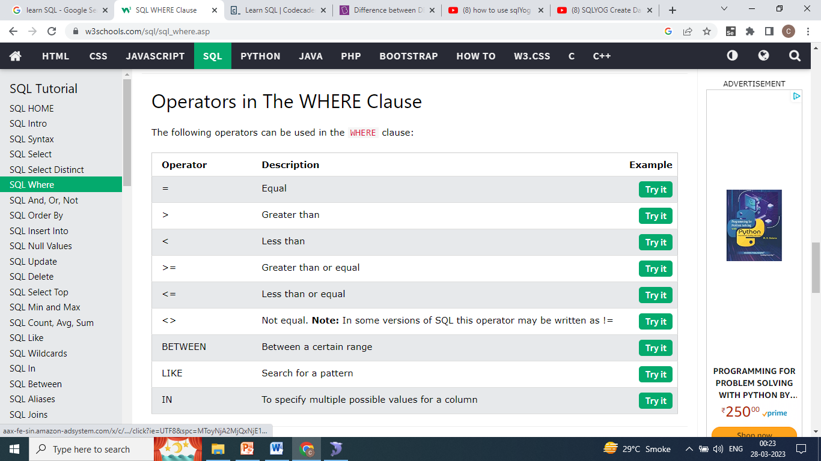

## The SQL AND, OR and NOT Operators

* The WHERE clause can be combined with AND, OR, and NOT operators.
* The AND and OR operators are used to filter records based on more than one condition:
  + The AND operator displays a record if all the conditions separated by AND are TRUE.
  + The OR operator displays a record if any of the conditions separated by OR is TRUE.
* The NOT operator displays a record if the condition(s) is NOT TRUE.

1. **SELECT * FROM** Employee **WHERE** Salary>25000 **AND** Emp_No>5;
2. **SELECT * FROM** Employee **WHERE** Salary>25000 **OR** Emp_No>5;
3. **SELECT * FROM** Employee **WHERE NOT** Salary=20000;

## Combining AND, OR and NOT

1. **SELECT * FROM** Employee **WHERE** Emp_No>=5 **AND** (Salary<20000 **OR** Salary>50000);
2. **SELECT * FROM** Employee **WHERE NOT** Salary<15000 **AND NOT** Salary>55000;

## The SQL ORDER BY Keyword

* The ORDER BY keyword is used to sort the result-set in ascending or descending order.
* The ORDER BY keyword sorts the records in ascending order by default. To sort the records in descending order, use the DESC keyword.

**SELECT * FROM** Employee **ORDER BY** Emp_Name;

**SELECT * FROM** Employee **ORDER BY** Emp_Name **DESC**;

## SQL NULL Values

## What is a NULL Value?

* A field with a NULL value is a field with no value.
* If a field in a table is optional, it is possible to insert a new record or update a record without adding a value to this field. Then, the field will be saved with a NULL value.
* Note: A NULL value is different from a zero value or a field that contains spaces. A field with a NULL value is one that has been left blank during record creation!
* We can use the IS NULL and IS NOT NULL operators.

**SELECT * FROM** Employee **WHERE** Salary **IS NULL**;

**SELECT * FROM** Employee **WHERE** Salary **IS NOT NULL**;

## The SQL UPDATE Statement

**UPDATE** Employee **SET** Salary=25000 **WHERE** Emp_Name='Dhara';

**UPDATE** Employee **SET** Salary=25000;

## The SQL DELETE Statement

**DELETE FROM** Employee **WHERE** Emp_No=104;

**DELETE FROM** Employee;

(Delete all records from the table)

## SQL MIN() and MAX() Functions

* The MIN() function returns the smallest value of the selected column.
* The MAX() function returns the largest value of the selected column.

**SELECT MIN**(Salary) **AS** Minimum_Salary **FROM** Employee;

**Output :**

|  |
| --- |
| Minimum_Salary |
| 15000 |

**SELECT MAX**(Salary) **AS** Maximum_Salary **FROM** Employee;

**Output :**

|  |
| --- |
| Maximum_Salary |
| 55000 |

## The SQL COUNT(), AVG() and SUM() Functions

* The COUNT() function returns the number of rows that matches a specified criterion.
* NULL values are not counted.

**SELECT COUNT**(Emp_No) Total_Employees **FROM** Employee;

**Output :**

|  |
| --- |
| Total_Employees |
| 9 |

,

**SELECT COUNT**(Emp_No) Total_Employees **FROM** Employee **WHERE** Emp_No>105;

**Output :**

|  |
| --- |
| Total_Employees |
| 6 |

,

* The AVG() function returns the average value of a numeric column.
* NULL values are ignored.

**SELECT AVG(**Salary) Average_Salary_IS **FROM** Employee**;**

**Output :**

|  |
| --- |
| Average_Salary_IS |
| 314444.4444 |

,

The SUM() function returns the total sum of a numeric column.

**SELECT AVG(**Salary) Average_Salary_IS **FROM** Employee **WHERE** Salary>25000**;**

**Output :**

|  |
| --- |
| Average_Salary_IS |
| 38600.0000 |

,

* The SUM() function returns the total sum of a numeric column.
* NULL values are ignored.

**SELECT SUM**(Emp_No) Sum_OF_ID **FROM** Employee **WHERE** Emp_No>105;

**Output :**

|  |
| --- |
| Sum_OF_ID |
| 646 |

**SELECT SUM**(Emp_No) Sum_OF_ID **FROM** Employee;

**Output :**

|  |
| --- |
| Sum_OF_ID |
| 959 |

## The SQL LIKE Operator

The LIKE operator is used in a WHERE clause to search for a specified pattern in a column.

There are two wildcards often used in conjunction with the LIKE operator:

* The percent sign (%) represents zero, one, or multiple characters
* The underscore sign (_) represents one, single character
* The percent sign and the underscore can also be used in combinations!
* You can also combine any number of conditions using AND or OR operators.

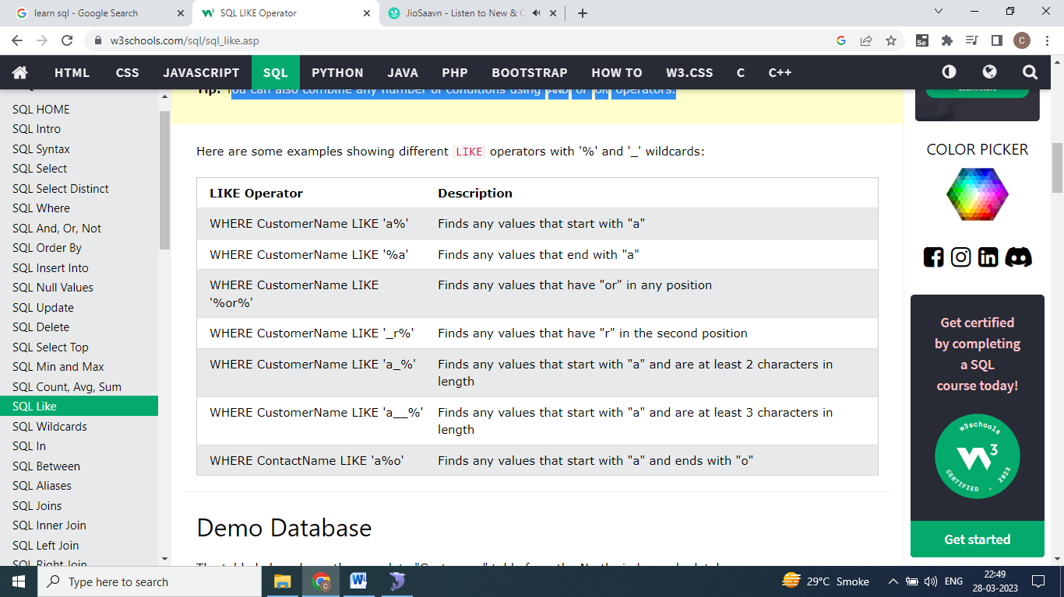

Name start with ‘A’ or ‘a’. Case doesn’t matter.

**SELECT * FROM** Employee **WHERE** Emp_Name **LIKE 'A%'**;

**Output:**

|  |  |  |
| --- | --- | --- |
| **Emp_No** | **Emp_Name** | **Salary** |
| 109 | Ameet | 55000 |

Name start with ‘A’ or ‘a’. Case doesn’t matter.

**SELECT * FROM** Employee **WHERE** Emp_Name **LIKE '%a'**;

**Output :**

|  |  |  |
| --- | --- | --- |
| **Emp_No** | **Emp_Name** | **Salary** |
| 105 | Bhavika | 25000 |
| 106 | Dhara | 28000 |
| 107 | Neha | 15000 |

Name the Employees that have ‘et’ in any position.

**SELECT * FROM** Employee **WHERE** Emp_Name **LIKE** '%et%';

**Output :**

|  |  |  |
| --- | --- | --- |
| **Emp_No** | **Emp_Name** | **Salary** |
| 108 | Saket | 35000 |
| 109 | Ameet | 55000 |

Name the Employees that have ‘h’ in the second position.

**SELECT * FROM** Employee **WHERE** Emp_Name **LIKE** '_h%';

**Output :**

|  |  |  |
| --- | --- | --- |
| **Emp_No** | **Emp_Name** | **Salary** |
| 105 | Bhavika | 25000 |
| 107 | Dhara | 15000 |
| 109 | Chinmayee | 45000 |

Name the Employees  that starts with "a" and are at least 3 characters in length.

**SELECT * FROM** Employee **WHERE** Emp_Name **LIKE** 'a__%';

**Output :**

|  |  |  |
| --- | --- | --- |
| **Emp_No** | **Emp_Name** | **Salary** |
| 109 | Ameet | 55000 |

All employees with a Name that starts with "c" and ends with "e".

**SELECT \*** **FROM**Employee **WHERE** Emp_Name **LIKE** 'c%e';

**Output :**

|  |  |  |
| --- | --- | --- |
| **Emp_No** | **Emp_Name** | **Salary** |
| 109 | Chinmayee | 45000 |

Selects all employees with a Emp_Name that does NOT start with "a":

**SELECT * FROM** Employee **WHERE**Emp_Name **NOT LIKE** 'a%';

## The SQL IN Operator

* The IN operator allows you to specify multiple values in a WHERE clause.
* The IN operator is a shorthand for multiple OR conditions.

**SELECT \*** **FROM** Employee **WHERE** Emp_Name **IN**('Chinmayee', 'Ameet','Rahul');

**Output :**

|  |  |  |
| --- | --- | --- |
| **Emp_No** | **Emp_Name** | **Salary** |
| 107 | Rahul | 25000 |
| 109 | Ameet | 55000 |
| 109 | Chinmayee | 45000 |

**SELECT \*** **FROM** Employee **WHERE** Emp_Name **NOT** **IN**('Chinmayee', 'Ameet','Rahul');

**Output :**

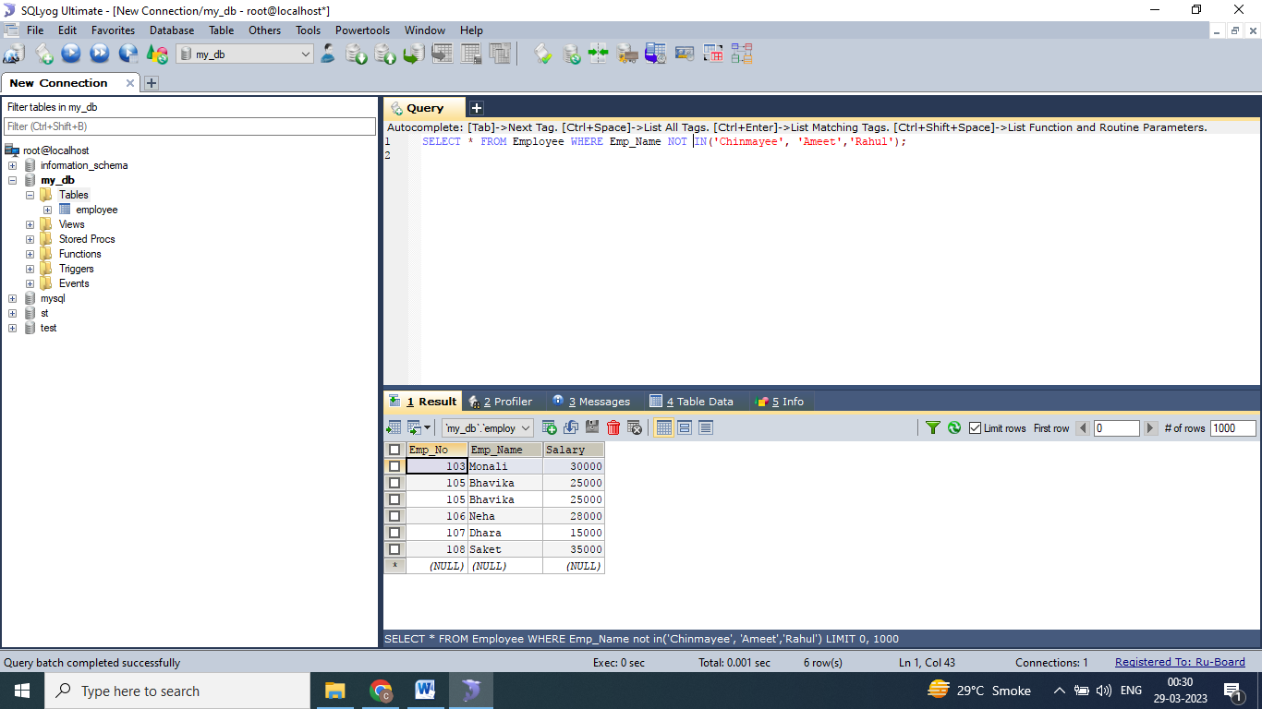

## The SQL BETWEEN Operator

* The BETWEEN operator selects values within a given range. The values can be numbers, text, or dates.
* The BETWEEN operator is inclusive: begin and end values are included.

**SELECT * FROM** Employee **WHERE** Salary **BETWEEN** 30000 **AND** 50000;

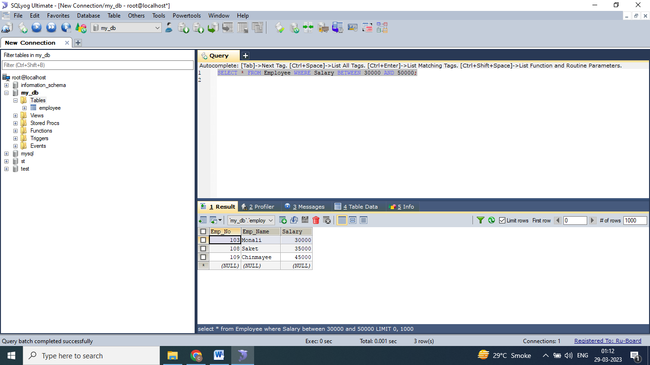

**SELECT * FROM** Employee **WHERE Salary NOT BETWEEN** 30000 **AND** 50000**;**

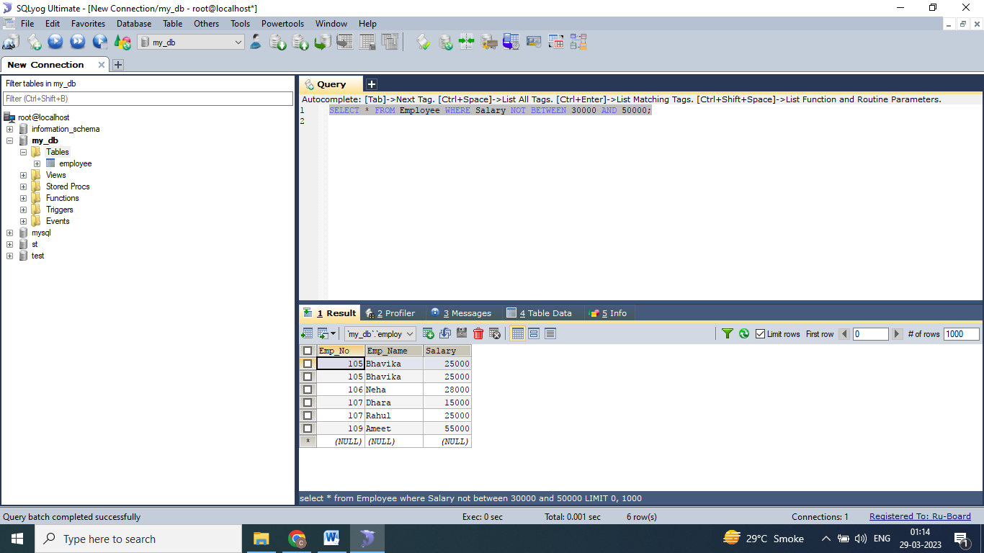

**SELECT * FROM** Employee **WHERE** Salary **NOT BETWEEN** 30000 **AND** 50000 **AND** Emp_No **NOT IN** (107);

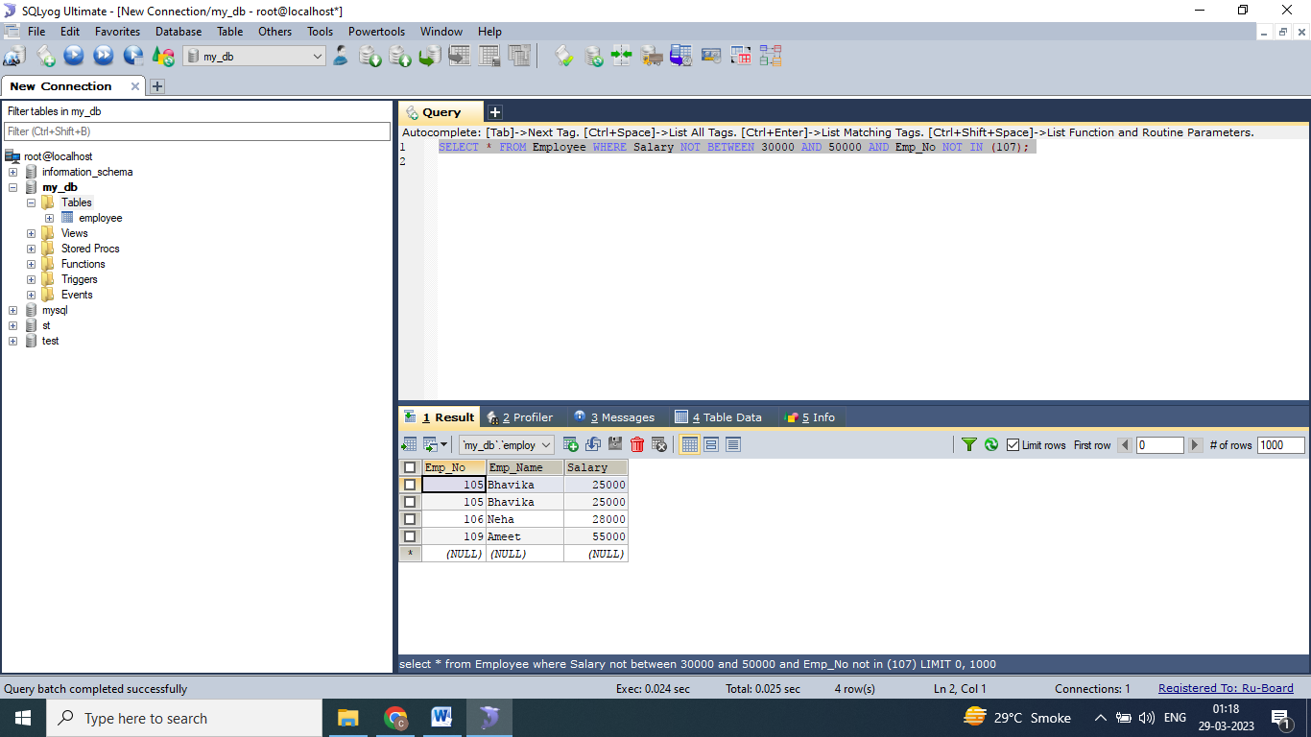

**SELECT * FROM** Employee **WHERE** Emp_Name **IN(**'Rahul','Ameet','Chinmayee') **ORDER BY** Emp_Name;

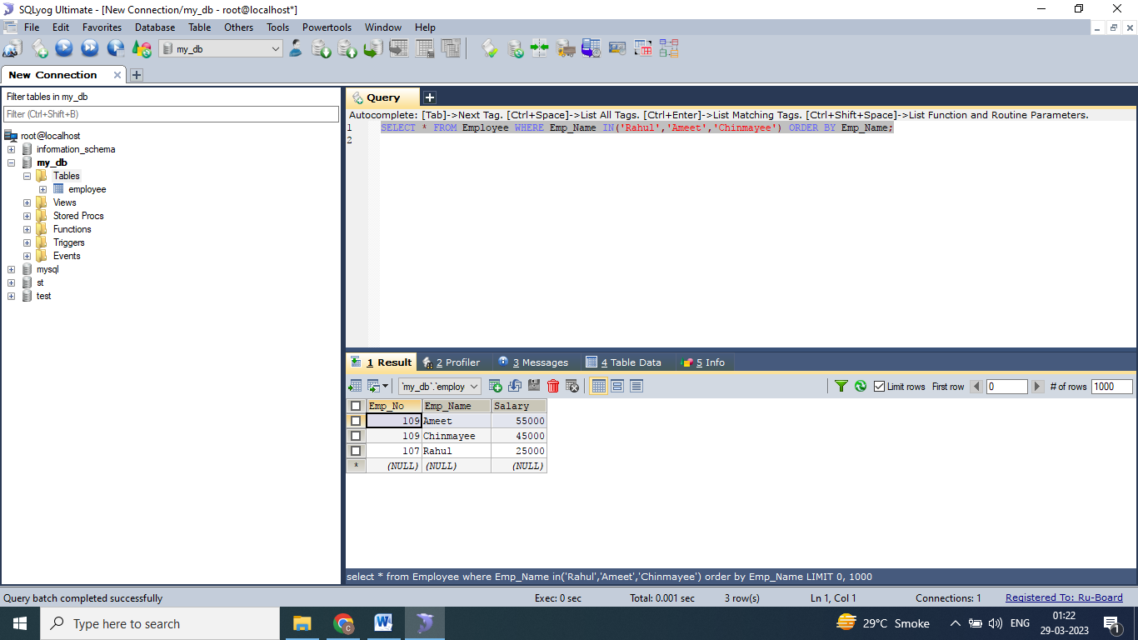

## BETWEEN Dates Example

* The following SQL statement selects all orders with an OrderDate between '01-July-1996' and '31-July-1996':

**SELECT * FROM** Orders  
**WHERE** OrderDate **BETWEEN** #07/01/1996# **AND** #07/31/1996#;

OR

**SELECT * FROM** Orders  
**WHERE** OrderDate **BETWEEN** '1996-07-01' **AND** '1996-07-31';

## SQL Aliases

* SQL aliases are used to give a table, or a column in a table, a temporary name.
* Aliases are often used to make column names more readable.
* An alias only exists for the duration of that query.
* An alias is created with the AS keyword.

**SELECT** C.Cust_ID, C.Customer_Name, E.Emp_No, E.Emp_Name **FROM** Customer C, Employee E **WHERE** C.Emp_No=E.Emp_No;

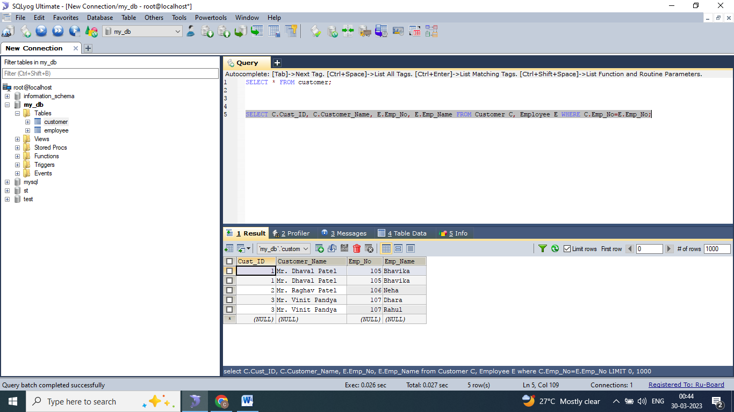

## SQL Constraints

* SQL constraints are used to specify rules for the data in a table.
* Constraints are used to limit the type of data that can go into a table. This ensures the accuracy and reliability of the data in the table. If there is any violation between the constraint and the data action, the action is aborted.
* Constraints can be column level or table level. Column level constraints apply to a column, and table level constraints apply to the whole table.

The following constraints are commonly used in SQL:

* NOT NULL - Ensures that a column cannot have a NULL value
* UNIQUE - Ensures that all values in a column are different
* PRIMARY KEY - A combination of a NOT NULL and UNIQUE. Uniquely identifies each row in a table
* FOREIGN KEY - Prevents actions that would destroy links between tables
* CHECK - Ensures that the values in a column satisfies a specific condition
* DEFAULT - Sets a default value for a column if no value is specified
* CREATE INDEX - Used to create and retrieve data from the database very quickly

## SQL NOT NULL Constraint

* By default, a column can hold NULL values.
* The NOT NULL constraint enforces a column to NOT accept NULL values.
* This enforces a field to always contain a value, which means that you cannot insert a new record, or update a record without adding a value to this field.

**CREATE TABLE** Persons

(

ID int **NOT NULL**,

LastName varchar(255) **NOT NULL**,

FirstName varchar(255) **NOT NULL**,

Age int

);

## SQL UNIQUE Constraint

* The UNIQUE constraint ensures that all values in a column are different.
* Both the UNIQUE and PRIMARY KEY constraints provide a guarantee for uniqueness for a column or set of columns.

**CREATE TABLE** Persons

(

ID int **NOT NULL** **UNIQUE**,

LastName varchar(255) **NOT NULL**,

FirstName varchar(255),

Age int

);

## SQL PRIMARY KEY Constraint

* The PRIMARY KEY constraint uniquely identifies each record in a table.
* Primary keys must contain UNIQUE values, and cannot contain NULL values.
* A table can have only ONE primary key; and in the table, this primary key can consist of single or multiple columns (fields).

**CREATE TABLE** Persons

(

ID int **NOT NULL PRIMARY KEY**,

LastName varchar(255) **NOT NULL**,

FirstName varchar(255),

Age int

);

## SQL FOREIGN KEY Constraint

* The FOREIGN KEY constraint is used to prevent actions that would destroy links between tables.
* A FOREIGN KEY is a field (or collection of fields) in one table, that refers to the [PRIMARY KEY](https://www.w3schools.com/sql/sql_primarykey.asp) in another table.
* The table with the foreign key is called the child table, and the table with the primary key is called the referenced or parent table.

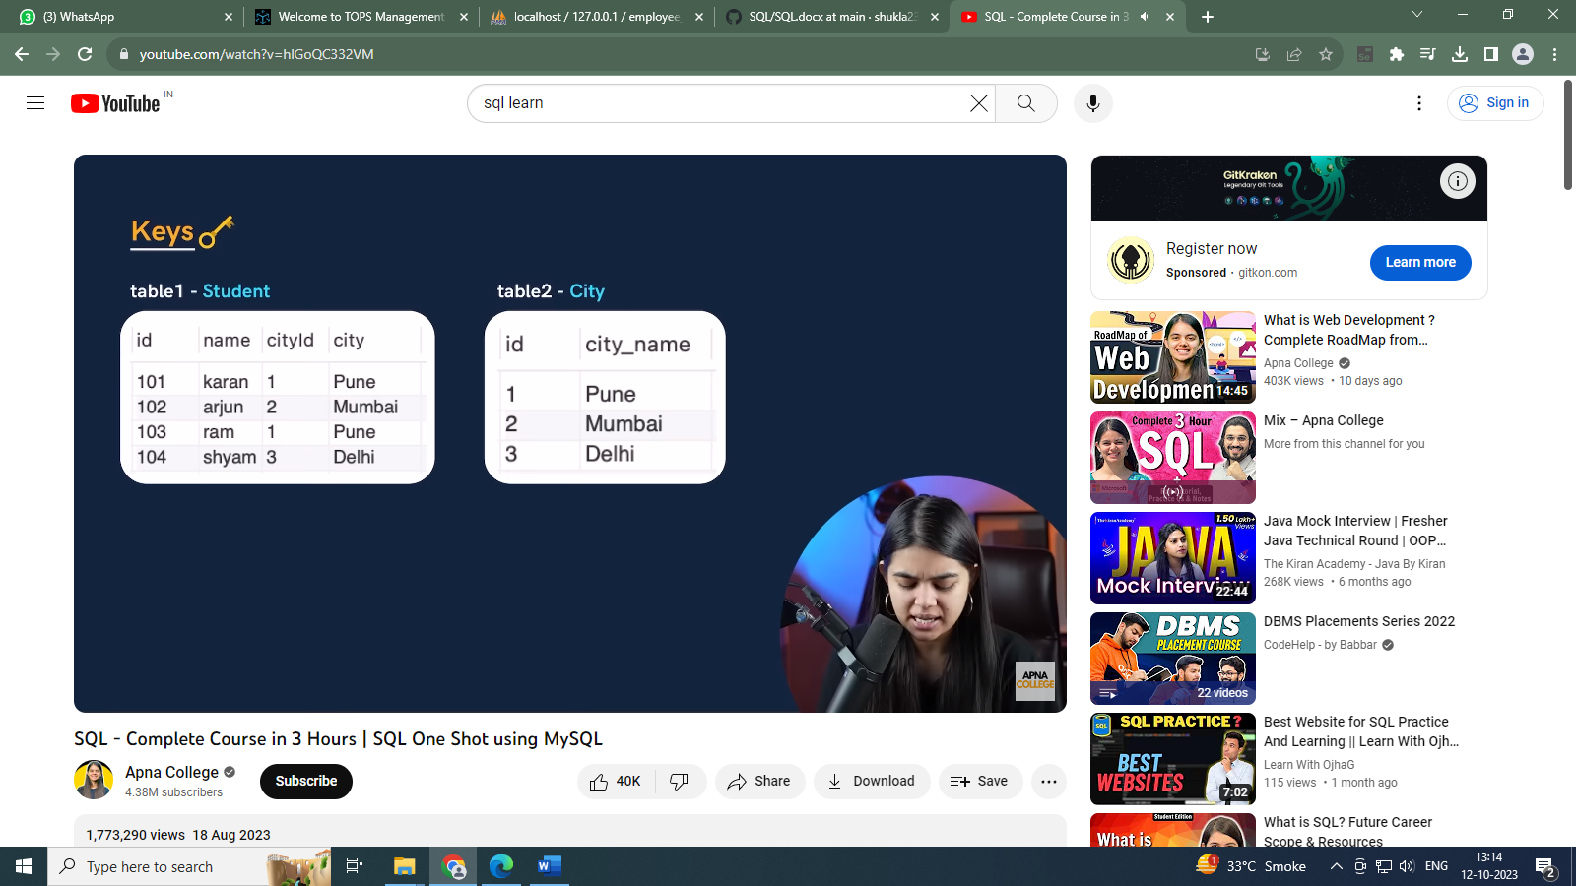

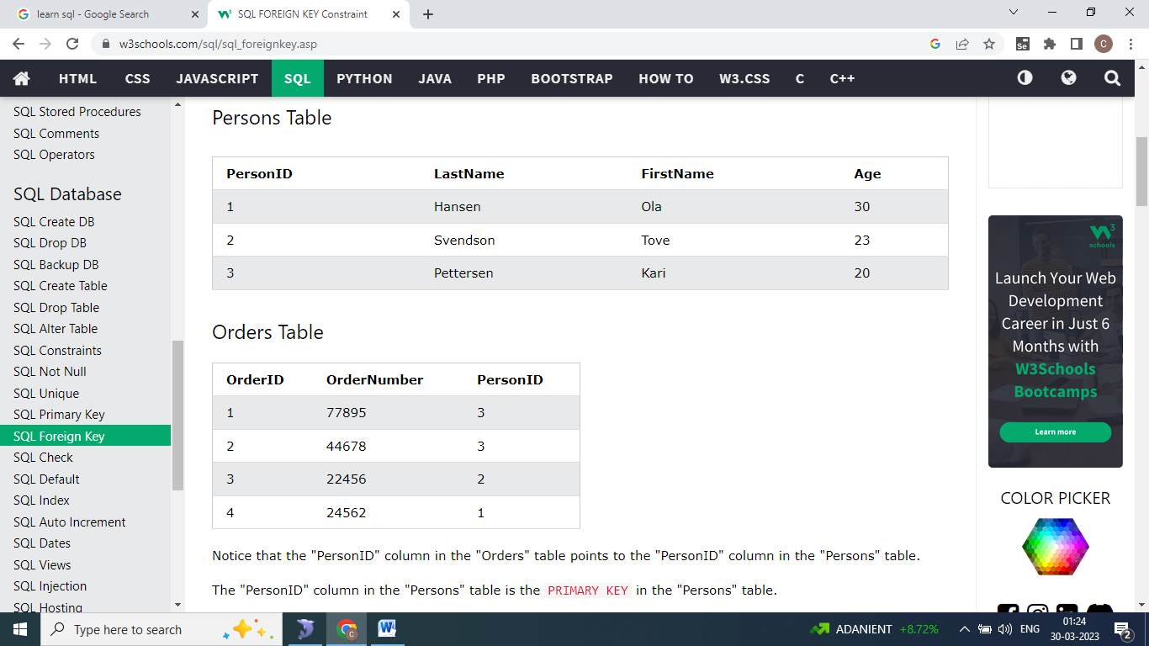

CREATE TABLE Orders (  
    OrderID int NOT NULL,  
    OrderNumber int NOT NULL,  
    PersonID int,  
    PRIMARY KEY (OrderID),  
    FOREIGN KEY (PersonID) REFERENCES Persons(PersonID)  
);

CREATE TABLE Orders (  
    OrderID int NOT NULL PRIMARY KEY,  
    OrderNumber int NOT NULL,  
    PersonID int FOREIGN KEY REFERENCES Persons(PersonID)  
);

## SQL CHECK Constraint

* The CHECK constraint is used to limit the value range that can be placed in a column.
* If you define a CHECK constraint on a column it will allow only certain values for this column.
* If you define a CHECK constraint on a table it can limit the values in certain columns based on values in other columns in the row.

CREATE TABLE Persons (  
    ID int NOT NULL,  
    LastName varchar(255) NOT NULL,  
    FirstName varchar(255),  
    Age int CHECK (Age>=18)  
);

## SQL DEFAULT Constraint

* The DEFAULT constraint is used to set a default value for a column.
* The default value will be added to all new records, if no other value is specified.

CREATE TABLE Persons (  
    ID int NOT NULL,  
    LastName varchar(255) NOT NULL,  
    FirstName varchar(255),  
    Age int,  
    City varchar(255) DEFAULT 'Sandnes'  
);

CREATE TABLE Orders (  
    ID int NOT NULL,  
    OrderNumber int NOT NULL,  
    OrderDate date DEFAULT GETDATE()  
);

## Alter keyword

**To add column :**

**ALTER TABLE**Customers **ADD**Email varchar(255);

**To delete column :**

**ALTER TABLE**Customers **DROP COLUMN**Email;

**To alter column:**

The ALTER COLUMN command is used to change the data type of a column in a table.

The following SQL changes the data type of the column named "BirthDate" in the "Employees" table to type year:

**ALTER TABLE** Employees **ALTER COLUMN** BirthDate year;

**To alter constraint:**

The ADD CONSTRAINT command is used to create a constraint after a table is already created.

The following SQL adds a constraint named "PK_Person" that is a PRIMARY KEY constraint on multiple columns (ID and LastName):

**ALTER TABLE** Persons  
**ADD CONSTRAINT** PK_Person **PRIMARY KEY** (ID,LastName);

**To drop the constraint :**

The DROP CONSTRAINT command is used to delete a UNIQUE, PRIMARY KEY, FOREIGN KEY, or CHECK constraint.

**ALTER TABLE** Persons **DROP CONSTRAINT** UC_Person;

## GROUP BY Clause

* Groups those rows that have the same values into summary rows.
* It collects data from multiple records and groups the results by one or more columns.
* Generally we use the group by with some aggregate functions.

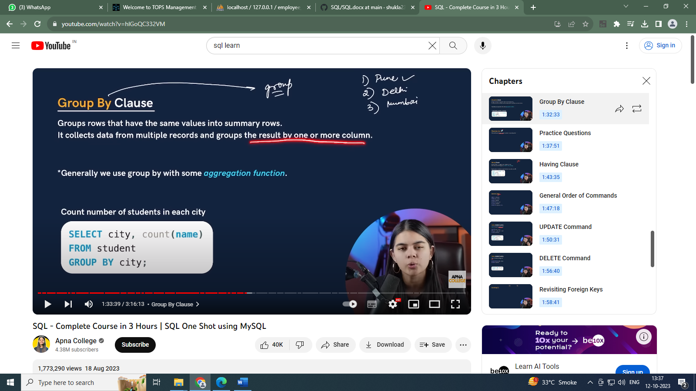

Query to find average marks in each city in ascending order.



## HAVING Clause



## SQL JOIN

* A JOIN clause is used to combine rows from two or more tables, based on a related column between them.
* The join keyword merges two or more tables and creates a temporary image of the merged table. Then according to the conditions provided, it extracts the required data from the image table, and once data is fetched, the temporary image of the merged tables is dumped.

## Different Types of SQL JOINs

|  |  |
| --- | --- |
| SQL INNER JOIN | **(INNER) JOIN:** Returns records that have matching values in both tables. |
| SQL LEFT JOIN | **LEFT (OUTER) JOIN:** Returns all records from the left table, and the matched records from the right table. |
| SQL RIGHT JOIN | **RIGHT (OUTER) JOIN:** Returns all records from the right table, and the matched records from the left table. |
| SQL FULL OUTER JOIN | **FULL (OUTER) JOIN:** Returns all records when there is a match in either left or right table. |

**INNER JOIN**

The INNER JOIN keyword selects records that have matching values in both tables.

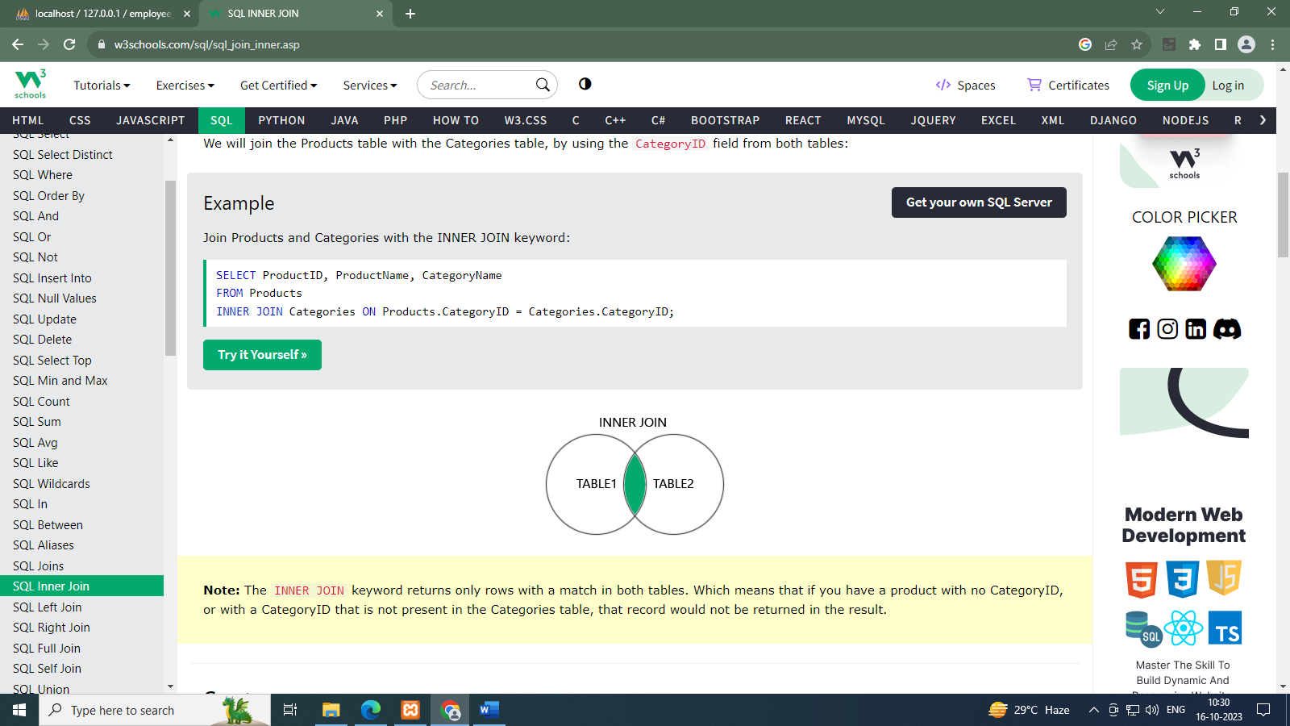

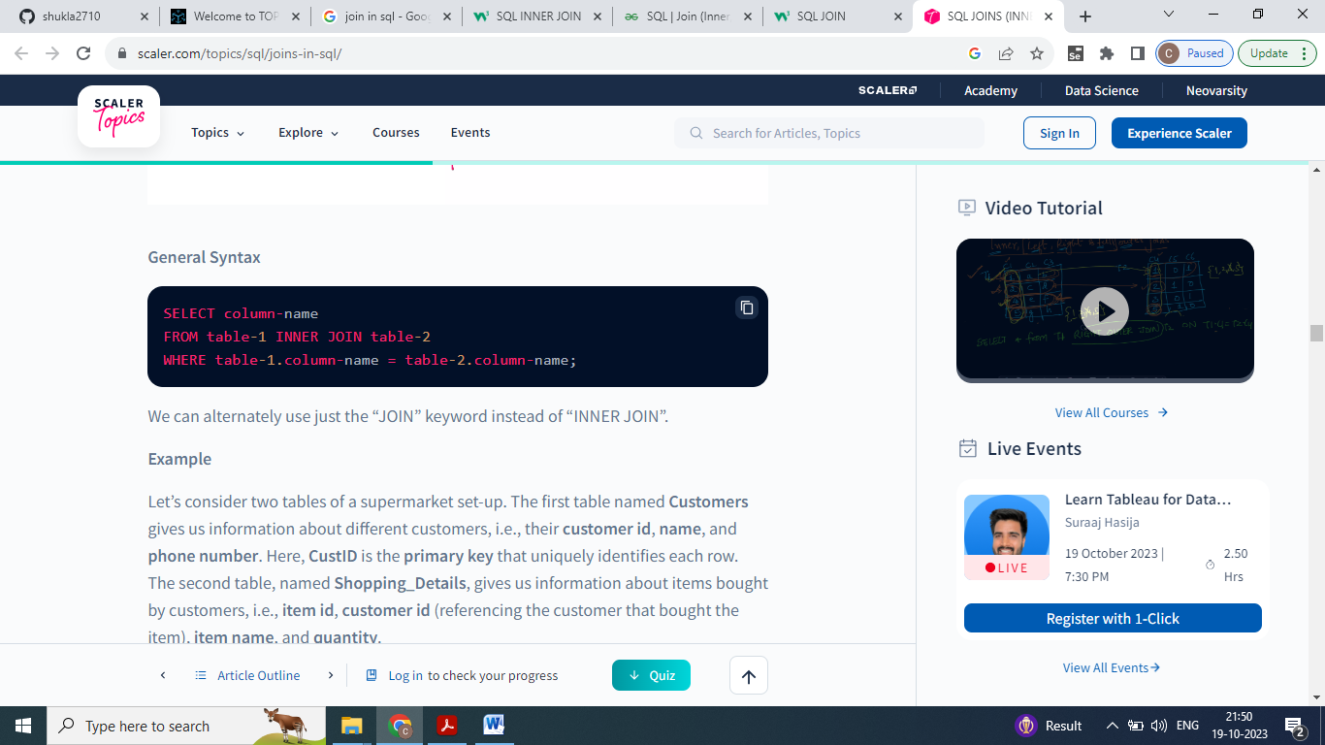

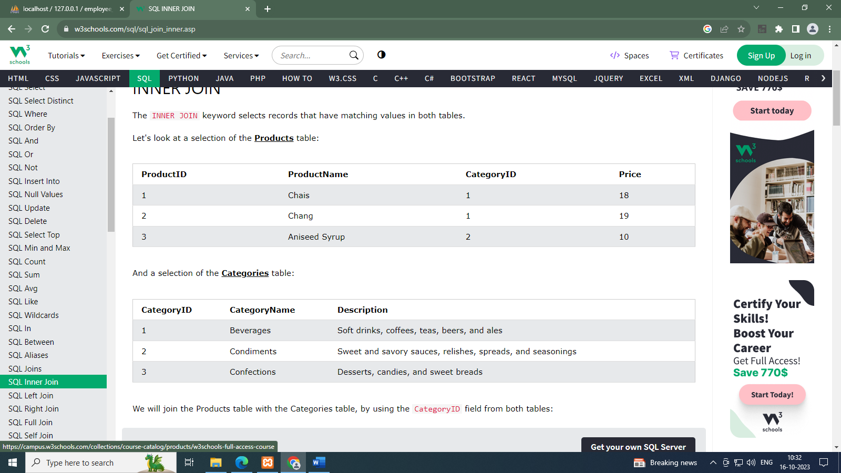

**SELECT** ProductID, ProductName, CategoryName  
**FROM** Products  
**INNER JOIN** Categories ON Products.CategoryID = Categories.CategoryID;

**OUTER JOIN**

SQL Outer joins give both matched and unmatched rows of data depending on the type of outer joins. These types are outer joins are sub-divided into the following types:

* **Left Outer Join**
* **Right Outer Join**
* **Full Outer Join**

**LEFT OUTER JOIN**

Rows belonging to the left-hand table as well as records available in both the tables, and not having values from the right-hand table are presented.



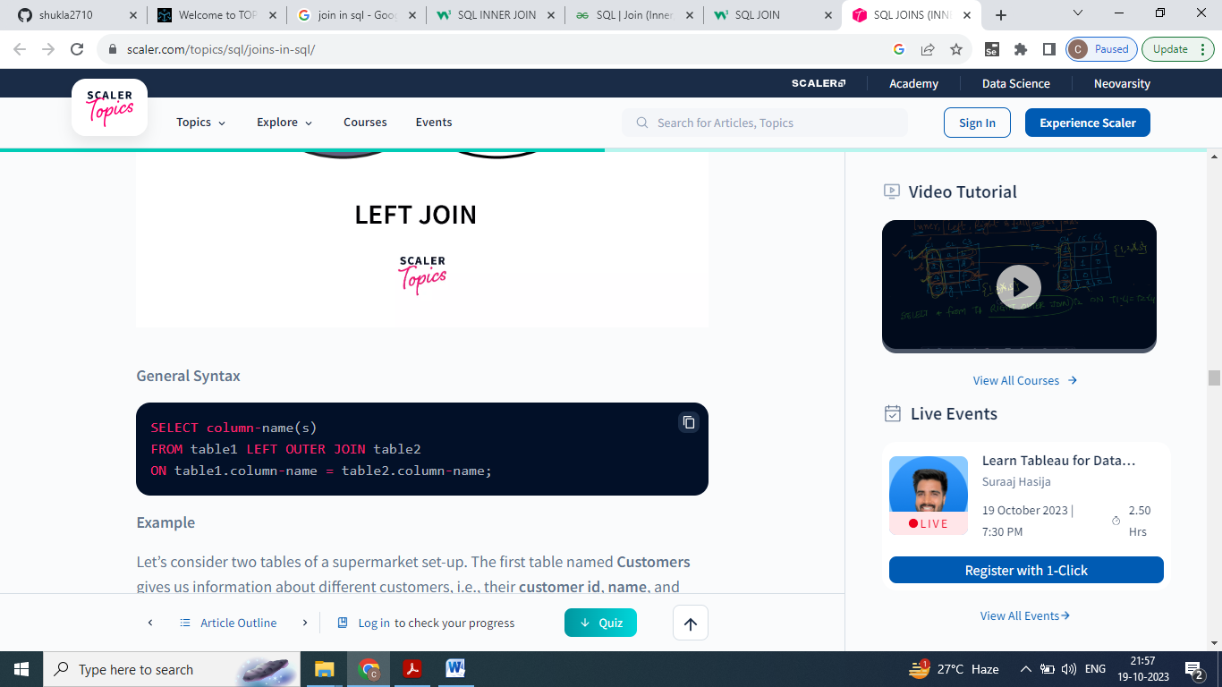

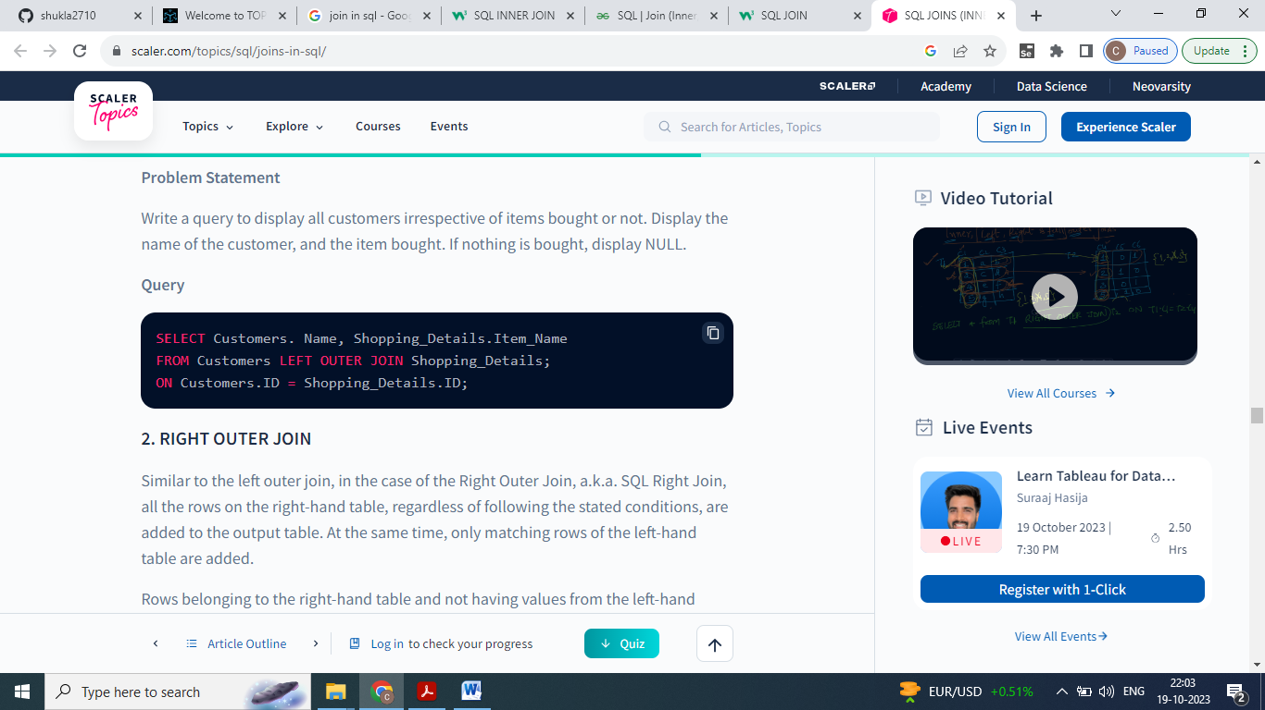

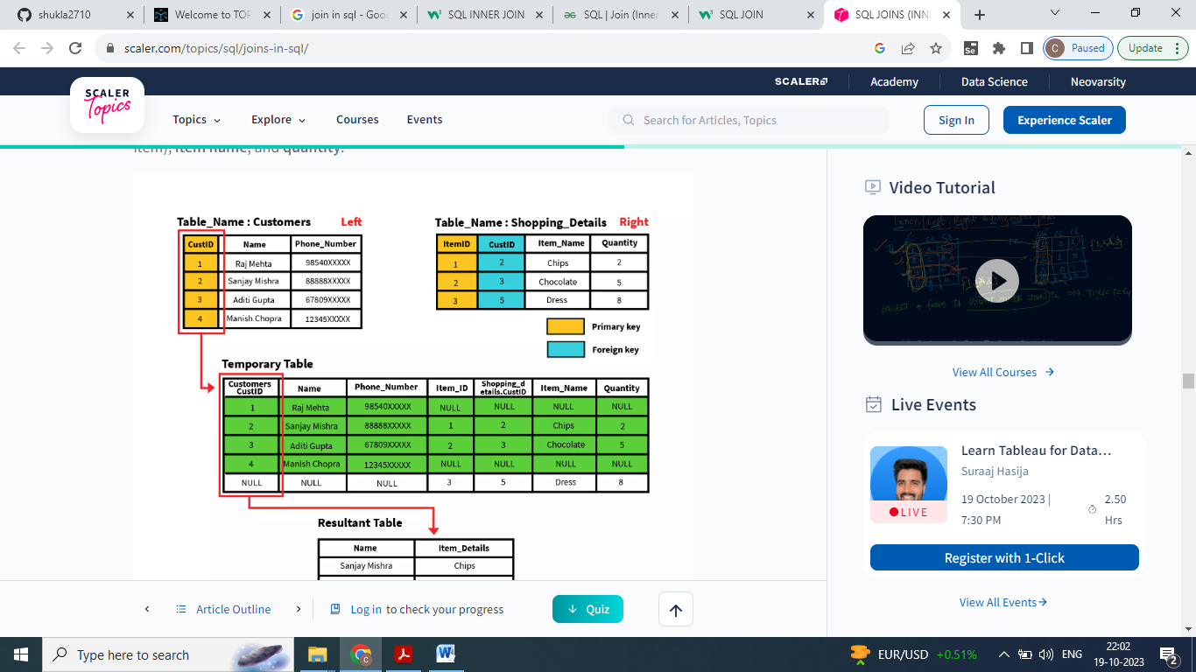

**RIGHT OUTER JOIN**

Rows belonging to the right-hand table as well as records available in both the tables, and not having values from the left-hand table are presented.



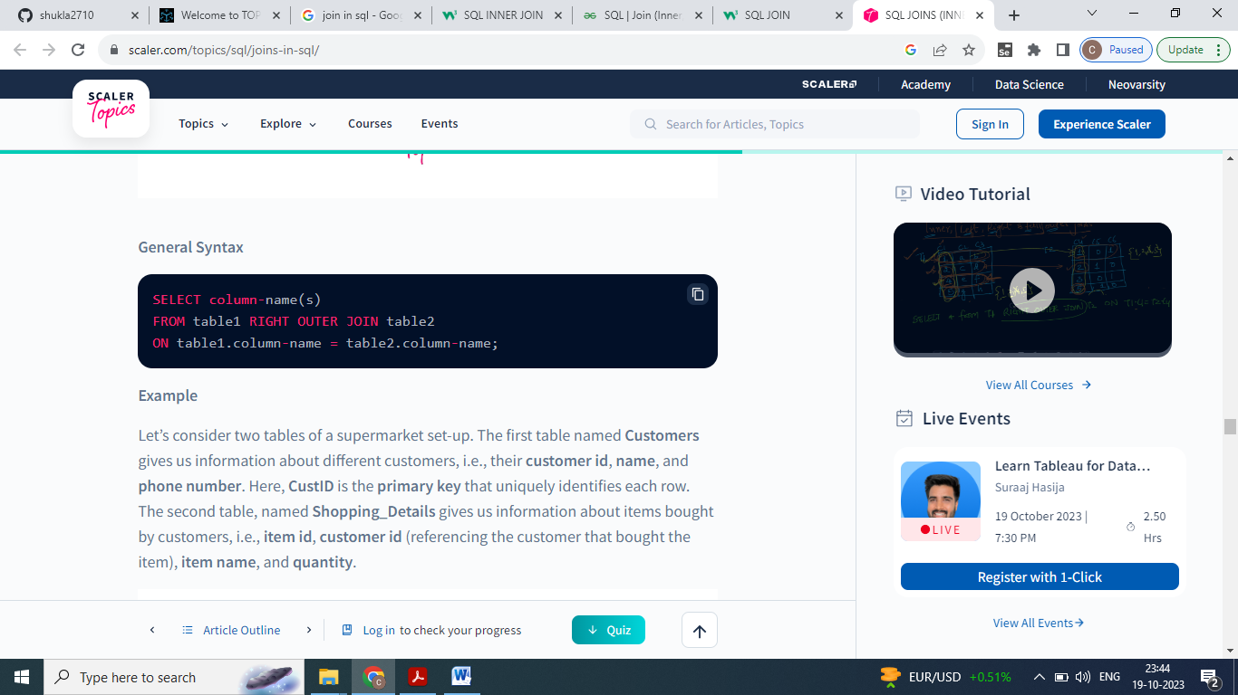

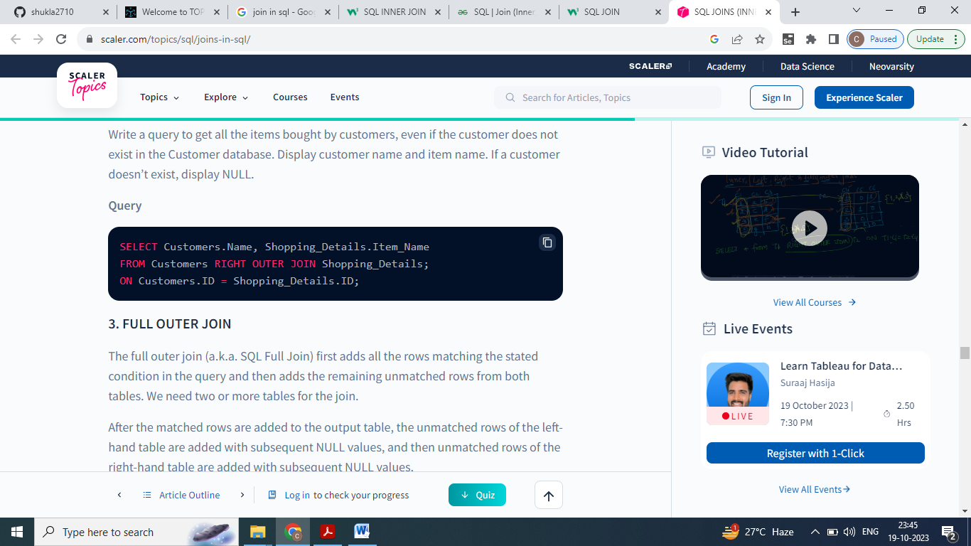

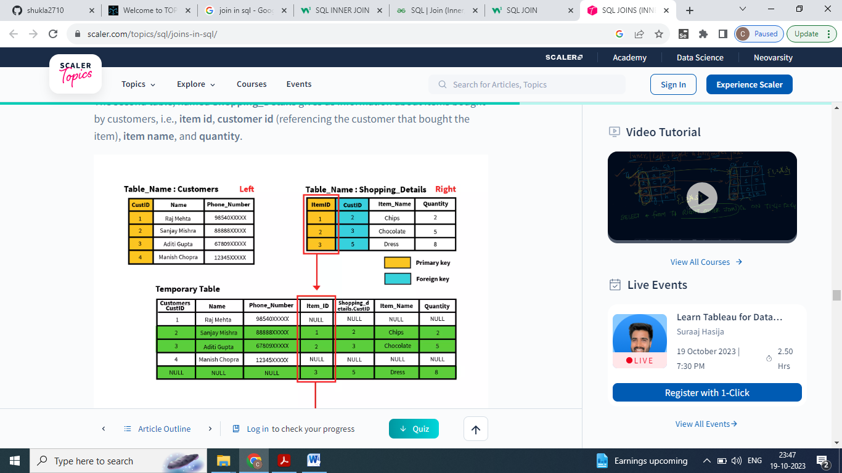

**FULL OUTER JOIN**

The full outer join (a.k.a. SQL Full Join) first adds all the rows matching the stated condition in the query and then adds the remaining unmatched rows from both tables. We need two or more tables for the join.



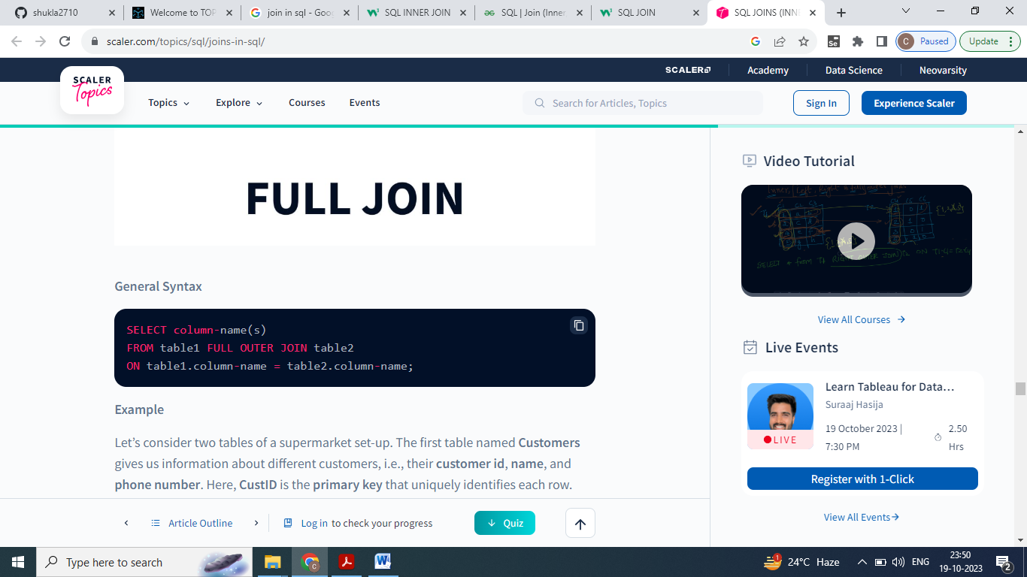

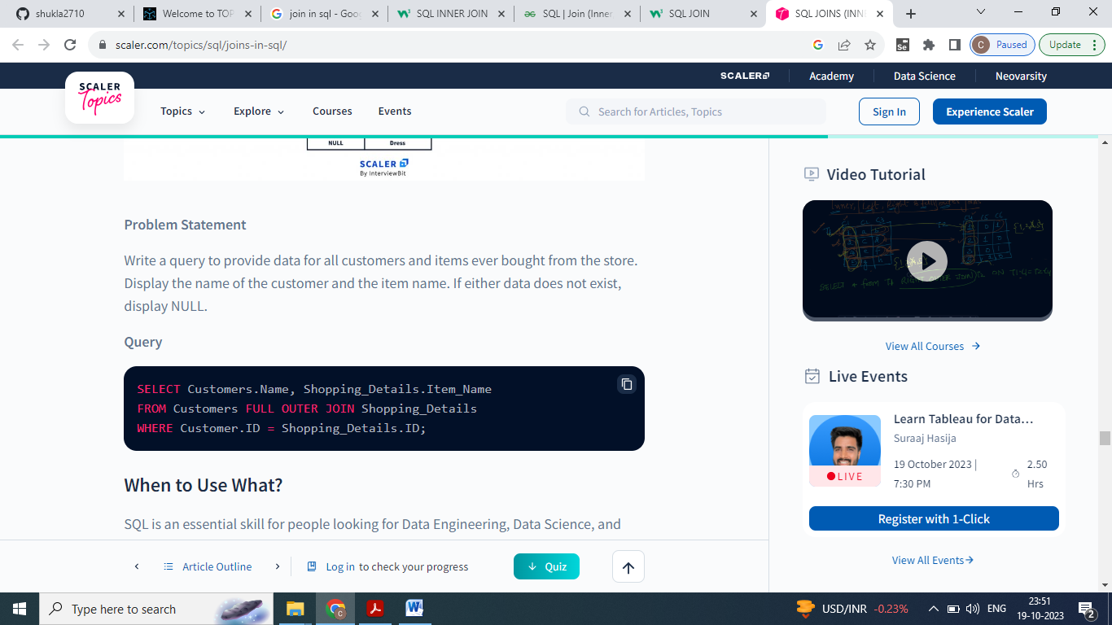

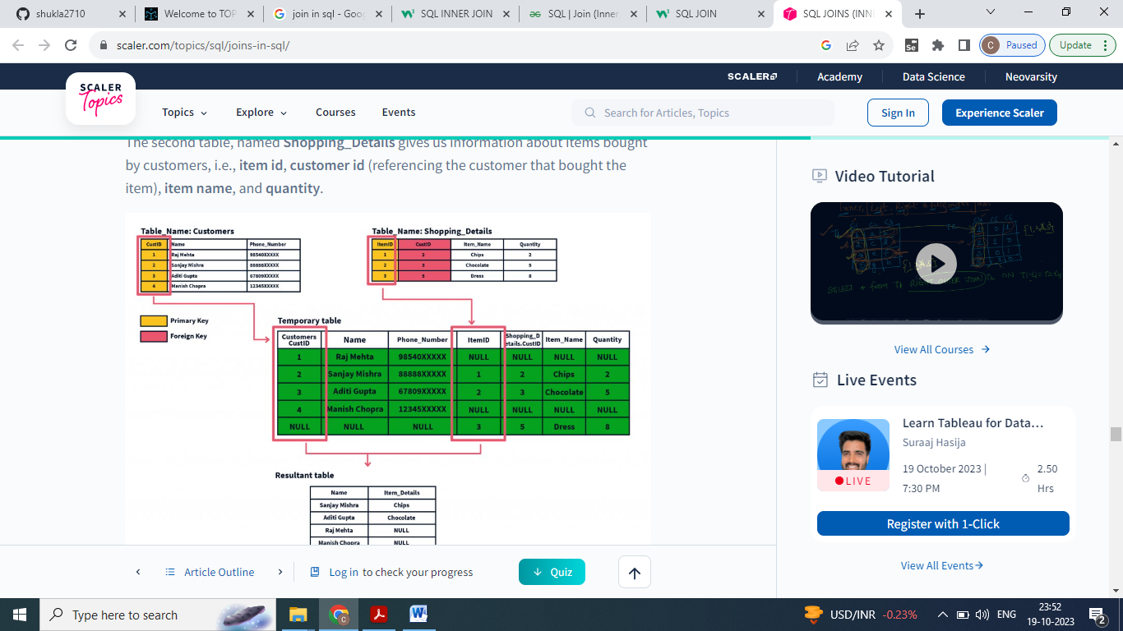

https://www.scaler.com/topics/difference-between-procedure-and-function-in-sql/